Môn: Lập trình đa nền tảng
Tên: Nguyễn Thành Danh
MSSV: 1150080046
Lab: Thực hành Lab01

Bài 1: Hoàn thiện các chức năng của một máy tính, có các phép +, -, *, /, %
File acitivy_bai1.xml:
<EditText
android:id="@+id/txtX"
android:hint="Nhập X"
android:gravity="center"
android:layout_width="match_parent"
android:layout_weight="1"
android:layout_height="0dp" />
<EditText
android:id="@+id/txtY"
android:hint="Nhập Y"
android:gravity="center"
android:layout_width="match_parent"
android:layout_weight="1"
android:layout_height="0dp" />
<TextView
android:id="@+id/txtResult"
android:layout_width="match_parent"
android:layout_weight="1"
android:layout_height="0dp"
android:gravity="center"
android:text="@string/result" />
<LinearLayout
android:layout_width="match_parent"
android:layout_height="0dp"
android:orientation="horizontal"
android:weightSum="5"
android:layout_weight="1">
<Button
android:id="@+id/btnPlus"
android:layout_width="0dp"
android:layout_weight="1"
android:text="@string/plus"
android:layout_height="match_parent" />
<Button
android:id="@+id/btnMinus"
android:layout_width="0dp"
android:layout_weight="1"
android:text="@string/minus"
android:layout_height="match_parent" />
<Button
android:id="@+id/btnMultiply"
android:layout_width="0dp"
android:layout_weight="1"
android:text="@string/multiply"
android:layout_height="match_parent" />
<Button
android:id="@+id/btnDivide"
android:layout_width="0dp"
android:layout_weight="1"
android:text="@string/divide"
android:layout_height="match_parent" />
<Button
android:id="@+id/btnModulo"
android:layout_width="0dp"
android:layout_weight="1"
android:text="@string/modulo"
android:layout_height="match_parent" />

File ActivityBai1.java
private void initControll() {
txtX = findViewById(R.id.txtX);
txtY = findViewById(R.id.txtY);
txtResult = findViewById(R.id.txtResult);
btnPlus = findViewById(R.id.btnPlus);
btnMinus = findViewById(R.id.btnMinus);
btnMultiply = findViewById(R.id.btnMultiply);
btnDivide = findViewById(R.id.btnDivide);
btnModulo = findViewById(R.id.btnModulo);
View.OnClickListener listener = new View.OnClickListener() {
@Override
public void onClick(View v) {
String sx = txtX.getText().toString().trim();
String sy = txtY.getText().toString().trim();
if (sx.isEmpty()) {
Toast.makeText(getApplicationContext(), "Vui lòng nhập X", Toast.LENGTH_SHORT).show();
return;
}
if (sy.isEmpty()) {
Toast.makeText(getApplicationContext(), "Vui lòng nhập Y", Toast.LENGTH_SHORT).show();
return;
}
int x = Integer.parseInt(sx);
int y = Integer.parseInt(sy);
double result = 0;
int id = v.getId();
if (id == R.id.btnPlus) {
result = x + y;
} else if (id == R.id.btnMinus) {
result = x - y;
} else if (id == R.id.btnMultiply) {
result = x * y;
} else if (id == R.id.btnDivide) {
if (y == 0) {
txtResult.setText("Không thể chia cho 0");
return;
}
result = (double) x / y;
} else if (id == R.id.btnModulo) {
if (y == 0) {
txtResult.setText("Không thể chia dư cho 0");
return;
}
result = x % y;
}
// In ra kết quả
if (result == (int) result) {
txtResult.setText(String.valueOf((int) result));
} else {
txtResult.setText(String.valueOf(result));
}
}
};
btnPlus.setOnClickListener(listener);
btnMinus.setOnClickListener(listener);
btnMultiply.setOnClickListener(listener);
btnDivide.setOnClickListener(listener);
btnModulo.setOnClickListener(listener);
}

Kết quả DEMO:
Phép (+)
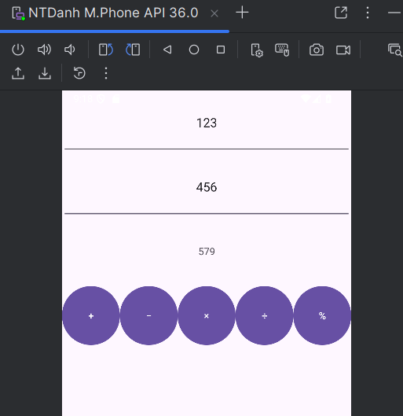
Phép (/)
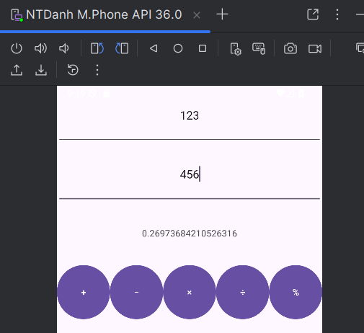
Phép (%)
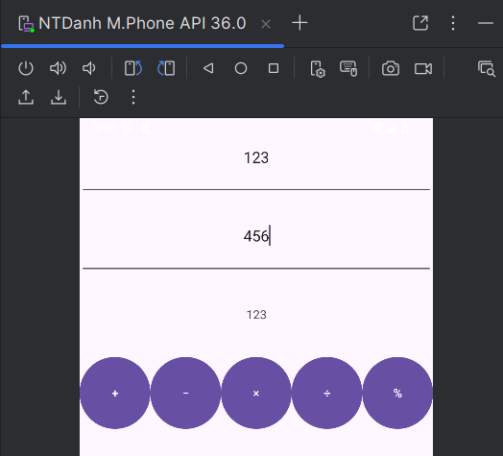

Bài 2: Xây dựng một ứng dụng cho phép mỗi khi người dùng nhấn nút thì xuất một số
ngẫu nhiên ra màn hình. Cải tiến để minh họa tung khối xúc xắc 6 mặt.

File activity_bai2.xml
<TextView
android:id="@+id/txtNumber"
android:layout_width="wrap_content"
android:layout_height="wrap_content"
android:text="Xúc xắc số: "
android:textSize="24sp"
android:layout_marginBottom="16dp" />
<ImageView
android:id="@+id/imgDice"
android:layout_width="100dp"
android:layout_height="100dp"
android:layout_marginBottom="16dp" />
<Button
android:id="@+id/btnRoll"
android:layout_width="wrap_content"
android:layout_height="wrap_content"
android:text="Roll Dice" />

File Bai2Acitivy.java
Khai báo:
private TextView txtNumber;
private ImageView imgDice;
private Button btnRoll;
private final int[] diceImages = {
R.drawable.dice_1,
R.drawable.dice_2,
R.drawable.dice_3,
R.drawable.dice_4,
R.drawable.dice_5,
R.drawable.dice_6
};
private final Random random = new Random();

Hàm onCreate() và hàm showResult()
@Override
protected void onCreate(Bundle savedInstanceState) {
super.onCreate(savedInstanceState);
setContentView(R.layout.activity_bai2);
txtNumber = findViewById(R.id.txtNumber);
imgDice = findViewById(R.id.imgDice);
btnRoll = findViewById(R.id.btnRoll);
btnRoll.setOnClickListener(new View.OnClickListener() {
@Override
public void onClick(View v) {
// random từ 1 đến 6
int value = random.nextInt(6) + 1;
showResult(value);
}
});
}
private void showResult(int value) {
txtNumber.setText("Xúc xắc số: " + value);
// Giá trị trong đoạn [1..6] -> Con trỏ trong Mảng [0..5]
imgDice.setImageResource(diceImages[value - 1]);
}

Kết quả DEMO:
Ban đầu:
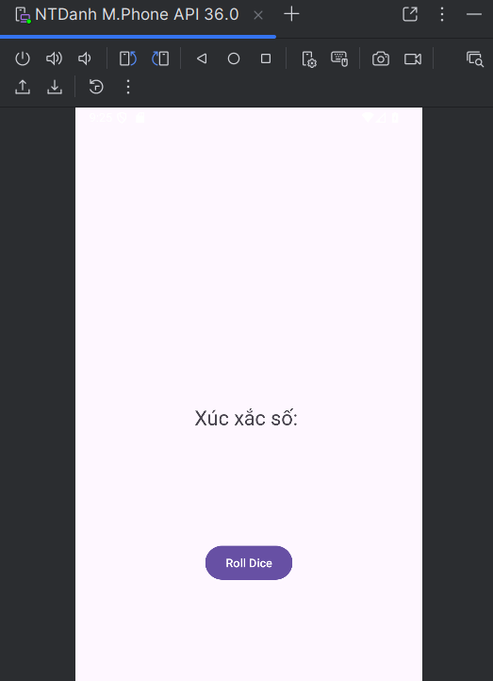

Nhấn nút Roll Dice:
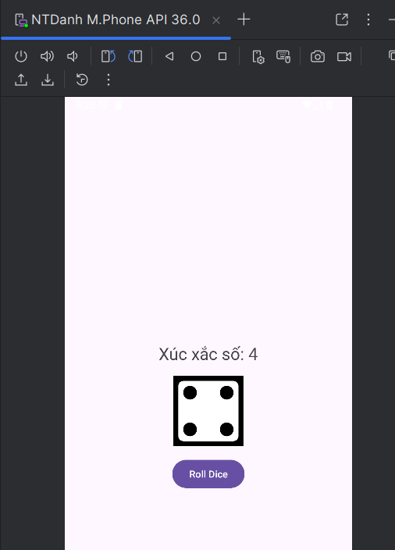

Bài 3: Viết chương trình cho phép gọi, nhắn tin trên Hệ điều hành Android.
File activity_bai3.xml

<EditText
android:id="@+id/txtPhone"
android:layout_width="match_parent"
android:layout_height="wrap_content"
android:hint="Enter phone number"
android:inputType="phone" />
<Button
android:id="@+id/btnCall"
android:layout_width="match_parent"
android:layout_height="wrap_content"
android:text="Call" />
<Button
android:id="@+id/btnSendSMS"
android:layout_width="match_parent"
android:layout_height="wrap_content"
android:text="Send SMS" />

File Bai3Activity.java:
@Override
protected void onCreate(Bundle savedInstanceState) {
super.onCreate(savedInstanceState);
setContentView(R.layout.activity_bai3);
txtPhone = findViewById(R.id.txtPhone);
btnCall = findViewById(R.id.btnCall);
btnSendSMS = findViewById(R.id.btnSendSMS);
// Nút gọi
btnCall.setOnClickListener(new View.OnClickListener() {
@Override
public void onClick(View v) {
String phoneNumber = txtPhone.getText().toString().trim();
if (phoneNumber.isEmpty()) {
Toast.makeText(getApplicationContext(), "Vui lòng nhập số điện thoại", Toast.LENGTH_SHORT).show();
return;
}
// Kích hoạt cuộc gọi
Intent callIntent = new Intent(Intent.ACTION_CALL);
callIntent.setData(Uri.parse("tel:" + phoneNumber));
// Kiểm tra quyền gọi
if (ActivityCompat.checkSelfPermission(Bai3Activity.this, Manifest.permission.CALL_PHONE)
!= PackageManager.PERMISSION_GRANTED) {
ActivityCompat.requestPermissions(Bai3Activity.this,
new String[]{Manifest.permission.CALL_PHONE}, 1);
return;
}
startActivity(callIntent);
}
});
// Nút NHẮN TIN
btnSendSMS.setOnClickListener(new View.OnClickListener() {
@Override
public void onClick(View v) {
String phoneNumber = txtPhone.getText().toString().trim();
if (phoneNumber.isEmpty()) {
Toast.makeText(getApplicationContext(), "Vui lòng nhập số điện thoại", Toast.LENGTH_SHORT).show();
return;
}
// Kích hoạt nhắn tin
Intent smsIntent = new Intent(Intent.ACTION_VIEW);
smsIntent.setData(Uri.parse("sms:" + phoneNumber));
smsIntent.putExtra("sms_body", "Hello from Lab1!");
startActivity(smsIntent);
}
});
}

Cấp quyền file AndroidManifest.xml
<uses-permission android:name="android.permission.CALL_PHONE" />
<uses-permission android:name="android.permission.SEND_SMS" />
<uses-permission android:name="android.permission.RECEIVE_SMS" />
<uses-permission android:name="android.permission.ACCESS_FINE_LOCATION" />
<uses-permission android:name="android.permission.ACCESS_COARSE_LOCATION" />
<uses-feature android:name="android.hardware.telephony" android:required="false" />
Kết quả DEMO:
Layout:
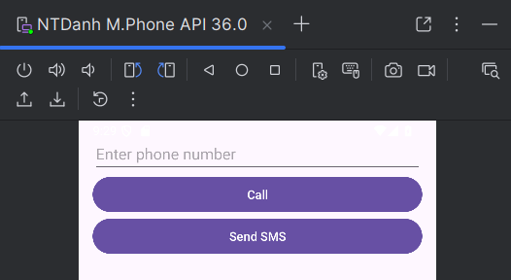

Nhập số đt, nhấn nút call:
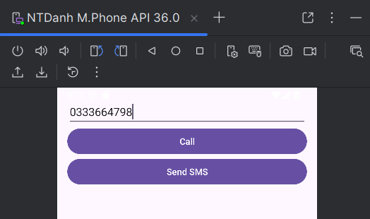
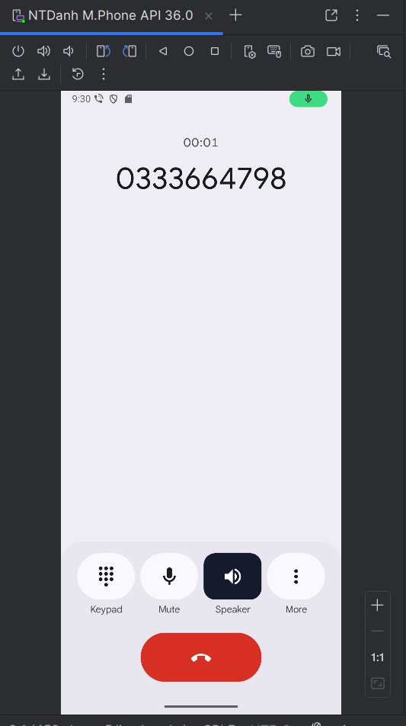
Nhấn nút Send SMS:
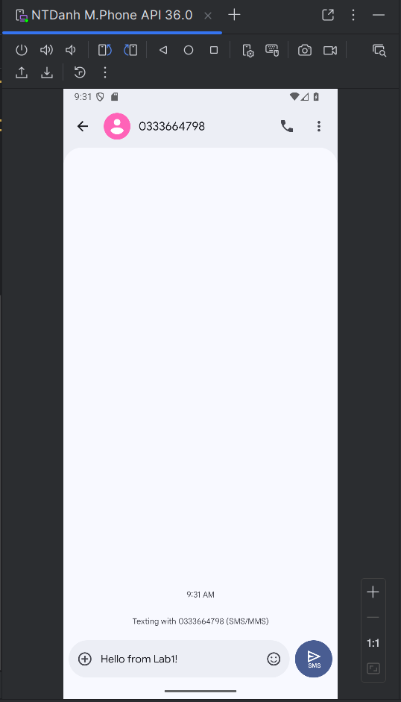

Lab: Thực hành Lab02

Bài 1: viết code để mỗi khi chạy lên sẽ ra một màu nền khác nhau và 1 icon khác nhau.
File m001_act_splash.xml
<ImageView
android:id="@+id/img_icon"
android:layout_width="128dp"
android:layout_height="128dp"
android:src="@drawable/pepe1"
tools:ignore="ContentDescription" />
<TextView
android:layout_width="wrap_content"
android:layout_height="wrap_content"
android:layout_marginTop="10dp"
android:fontFamily="sans-serif-light"
android:text="@string/app_name"
android:textColor="@color/white"
android:textSize="24sp" />

File M001ActSplash.java
public class M001ActSplash extends AppCompatActivity {
private LinearLayout mainLayout;
private ImageView imgIcon;
private Random random = new Random();
@Override
protected void onCreate(Bundle savedInstanceState) {
super.onCreate(savedInstanceState);
setContentView(R.layout.m001_act_splash);
mainLayout = findViewById(R.id.main_layout);
imgIcon = findViewById(R.id.img_icon);
// Thay đổi màu nền ngẫu nhiên
int[] colors = {
R.color.red,
R.color.green,
R.color.blue,
R.color.yellow,
R.color.purple
};
int randomColor = colors[random.nextInt(colors.length)];
mainLayout.setBackgroundColor(getResources().getColor(randomColor, null));
// Thay đổi icon ngẫu nhiên
int[] icons = {
R.drawable.pepe1,
R.drawable.pepe2,
R.drawable.pepe3
};
int randomIcon = icons[random.nextInt(icons.length)];
imgIcon.setImageResource(randomIcon);
}
}

Kết quả DEMO rerun app nhiều lần:
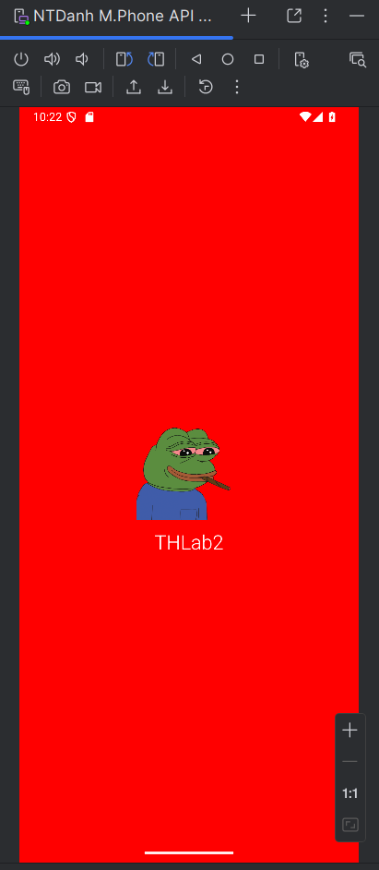
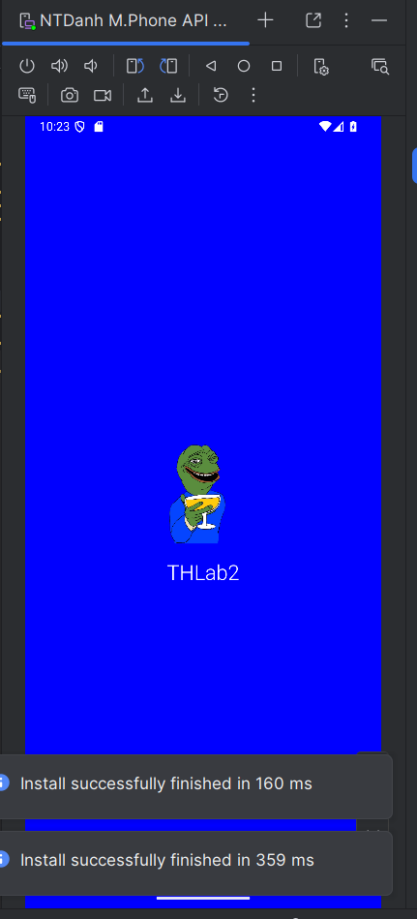

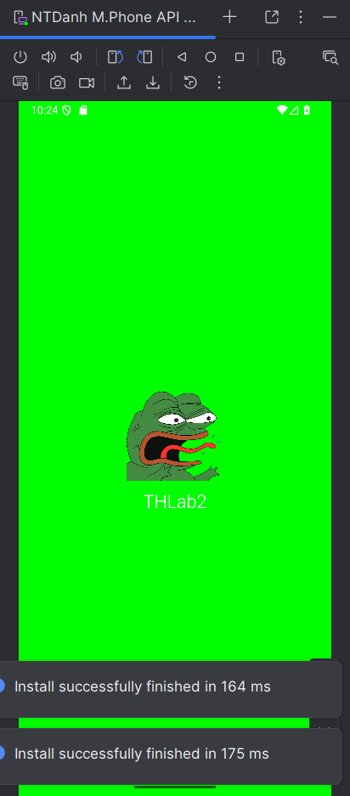
Bài 2: sử dụng Custom ProgressBar để làm giao diện đẹp hơn.
File m001_act_splash.xml

<LinearLayout
android:layout_width="match_parent"
android:layout_height="match_parent"
android:gravity="center"
android:orientation="vertical">
<ImageView
android:layout_width="128dp"
android:layout_height="128dp"
android:src="@drawable/pepe1"
tools:ignore="ContentDescription" />
<TextView
android:layout_width="wrap_content"
android:layout_height="wrap_content"
android:layout_marginTop="10dp"
android:fontFamily="sans-serif-light"
android:text="@string/app_name"
android:textColor="@color/white"
android:textSize="24sp" />
</LinearLayout>
<include layout="@layout/item_loading" />

File M001ActSplash.java
public class M001ActSplash extends AppCompatActivity {
@Override
protected void onCreate(Bundle savedInstanceState){
super.onCreate(savedInstanceState);
setContentView(R.layout.m001_act_splash);
}
}

Kết quả DEMO:

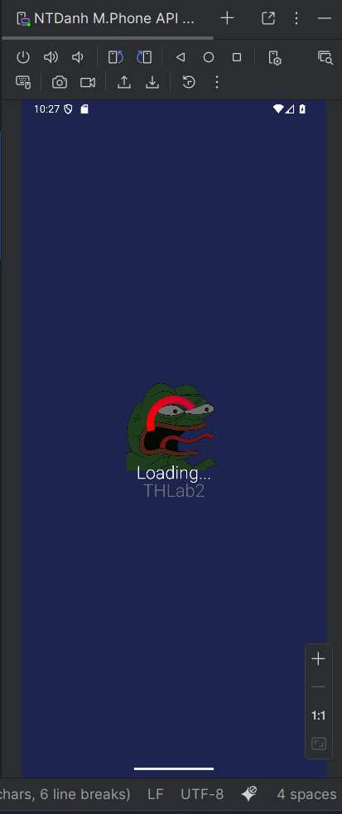
Bài 3: Lập trình để khi bấm vào icon (phone) thì chuyển về cuộc gọi, sử dụng Intent.

File m001_act_profile.xml
<!-- Header (ảnh nền, tên, avatar) -->
<FrameLayout
android:layout_width="match_parent"
android:layout_height="350dp">
<ImageView
android:layout_width="match_parent"
android:layout_height="300dp"
android:scaleType="centerCrop"
android:src="@drawable/bg_connor"
tools:ignore="ContentDescription" />
<TextView
android:layout_width="wrap_content"
android:layout_height="wrap_content"
android:layout_gravity="bottom"
android:layout_marginStart="70dp"
android:layout_marginBottom="80dp"
android:fontFamily="sans-serif"
android:text="@string/txt_name"
android:textColor="@color/white"
android:textSize="40sp" />
<ImageView
android:layout_width="80dp"
android:layout_height="80dp"
android:layout_gravity="end|bottom"
android:layout_marginEnd="20dp"
android:layout_marginBottom="20dp"
android:background="@drawable/bg_oval"
android:padding="20dp" />
</FrameLayout>
<!-- Phone section -->
<TableRow
android:layout_width="match_parent"
android:layout_height="wrap_content"
android:padding="20dp">
<ImageView
android:id="@+id/img_phone1"
android:layout_width="60dp"
android:layout_height="60dp"
android:padding="10dp"
android:src="@drawable/ic_phone"
app:tint="@color/blue"
tools:ignore="ContentDescription" />
<LinearLayout
android:layout_width="match_parent"
android:layout_height="wrap_content"
android:layout_marginStart="5dp"
android:orientation="vertical">
<TextView
android:id="@+id/txt_phone1"
android:layout_width="match_parent"
android:layout_height="wrap_content"
android:text="@string/txt_phone1"
android:textColor="@color/gray_dark"
android:textSize="20sp" />
<TextView
android:id="@+id/txt_title_mobile"
android:layout_width="match_parent"
android:layout_height="wrap_content"
android:layout_marginTop="5dp"
android:text="@string/txt_title_mobile"
android:textColor="@color/gray_mid"
android:textSize="18sp" />
<View
android:layout_width="match_parent"
android:layout_height="0.5dp"
android:layout_marginTop="30dp"
android:background="@color/gray_mid" />
</LinearLayout>
</TableRow>
<!-- Email section -->
<TableRow
android:layout_width="match_parent"
android:layout_height="wrap_content"
android:padding="20dp">
<ImageView
android:id="@+id/img_email"
android:layout_width="60dp"
android:layout_height="60dp"
android:padding="10dp"
android:src="@drawable/ic_email"
app:tint="@color/blue"
tools:ignore="ContentDescription" />
<LinearLayout
android:layout_width="match_parent"
android:layout_height="wrap_content"
android:layout_marginStart="30dp"
android:orientation="vertical">
<TextView
android:id="@+id/txt_email"
android:layout_width="match_parent"
android:layout_height="wrap_content"
android:text="@string/txt_email"
android:textColor="@color/gray_dark"
android:textSize="20sp" />
<TextView
android:layout_width="match_parent"
android:layout_height="wrap_content"
android:layout_marginTop="5dp"
android:text="@string/txt_title_mobile"
android:textColor="@color/gray_mid"
android:textSize="18sp" />
</LinearLayout>
</TableRow>

File M001ActProfile.java
@Override
protected void onCreate(Bundle savedInstanceState) {
super.onCreate(savedInstanceState);
setContentView(R.layout.m001_act_profile);
imgPhone1 = findViewById(R.id.img_phone1);
txtPhone1 = findViewById(R.id.txt_phone1);
// bấm icon gọi
imgPhone1.setOnClickListener(v -> makePhoneCall());
txtPhone1.setOnClickListener(v -> makePhoneCall());
}
private void makePhoneCall() {
String phoneNumber = txtPhone1.getText().toString().trim();
phoneNumber = phoneNumber.replaceAll("[^0-9]+", "");
if (phoneNumber.isEmpty()) {
Toast.makeText(this, "Phone number is empty", Toast.LENGTH_SHORT).show();
return;
}
if (ContextCompat.checkSelfPermission(this, Manifest.permission.CALL_PHONE)
!= PackageManager.PERMISSION_GRANTED) {
ActivityCompat.requestPermissions(
this,
new String[]{Manifest.permission.CALL_PHONE},
REQUEST_CALL_PHONE
);
return;
}
// Cấp quyền -> gọi
Intent callIntent = new Intent(Intent.ACTION_CALL);
callIntent.setData(Uri.parse("tel:" + phoneNumber));
try {
startActivity(callIntent);
} catch (SecurityException e) {
Toast.makeText(this, "Call failed: " + e.getMessage(), Toast.LENGTH_SHORT).show();
}
}
// Kết quả xin quyền
@Override
public void onRequestPermissionsResult(int requestCode,
@NonNull String[] permissions,
@NonNull int[] grantResults) {
super.onRequestPermissionsResult(requestCode, permissions, grantResults);
if (requestCode == REQUEST_CALL_PHONE) {
if (grantResults.length > 0 && grantResults[0] == PackageManager.PERMISSION_GRANTED) {
// user vừa cho quyền -> gọi tiếp
makePhoneCall();
} else {
Toast.makeText(this, "Permission CALL_PHONE denied", Toast.LENGTH_SHORT).show();
}
}
}

Kết quả DEMO:
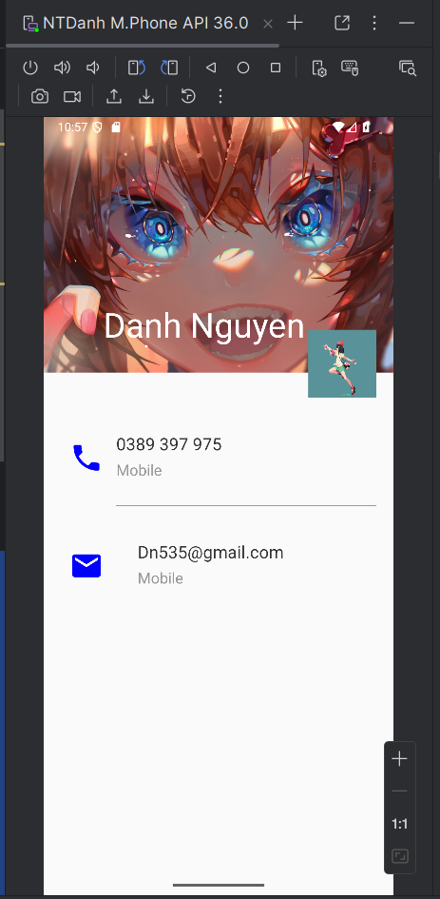
Bấm vào icon phone để gọi tới:
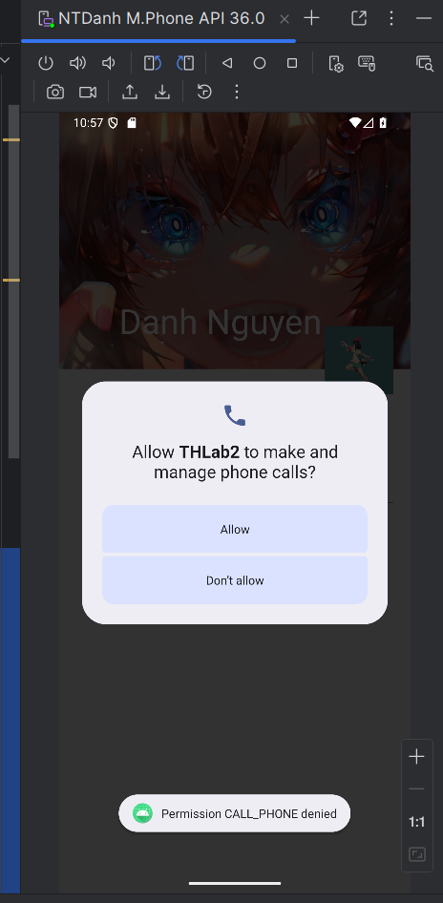
Cấp quyền và gọi:
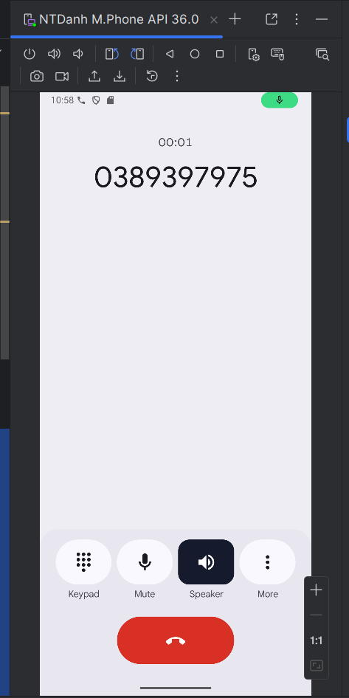
Bài 4:
File activity_main.xml:
<TextView
android:layout_width="wrap_content"
android:layout_height="wrap_content"
android:text="Lab 2 Menu"
android:textSize="24sp"
android:textColor="@color/black"
android:layout_marginBottom="32dp" />
<Button
android:id="@+id/btn_splash"
android:layout_width="match_parent"
android:layout_height="wrap_content"
android:text="Go to Splash Screen"
android:layout_marginBottom="16dp" />
<Button
android:id="@+id/btn_profile"
android:layout_width="match_parent"
android:layout_height="wrap_content"
android:text="Go to Profile Screen" />
File MainActivity.java
@Override
protected void onCreate(Bundle savedInstanceState) {
super.onCreate(savedInstanceState);
setContentView(R.layout.activity_main);
Button btnSplash = findViewById(R.id.btn_splash);
Button btnProfile = findViewById(R.id.btn_profile);
// Nút chuyển sang Splash Screen
btnSplash.setOnClickListener(v -> {
Intent intent = new Intent(MainActivity.this, M001ActSplash.class);
startActivity(intent);
});
// Nút chuyển sang Profile Screen
btnProfile.setOnClickListener(v -> {
Intent intent = new Intent(MainActivity.this, M001ActProfile.class);
startActivity(intent);
});
}

Kết quả DEMO:
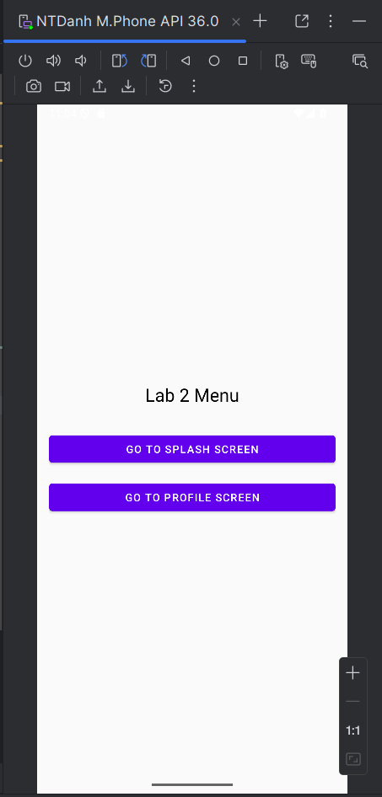

Nhấn vào GO TO SPLASH SCREEN:
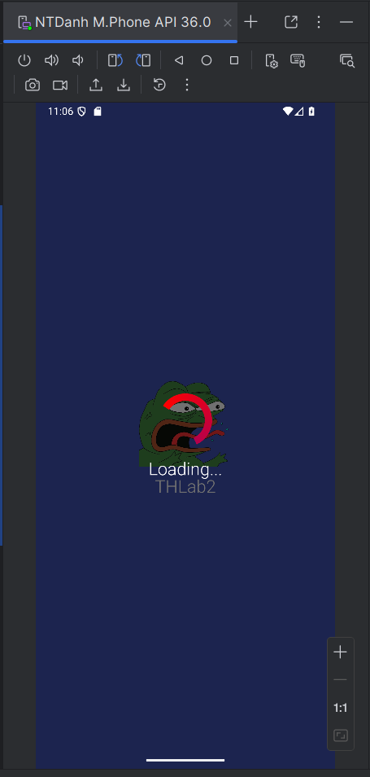

Nhấn vào GO TO SPLASH PROFILE SCREEN:
